Name ________________________________
MONDAY
Directions: Solve each of the following

1. 3^ + 2^ 2. 7! ) - 2! ) 3. 8! @ + 4! @

4. t+t 5.n-v

6. What are three common multiples for 4, 8, and 12?

7. Find the least common multiple for 3$ and 2^ ?

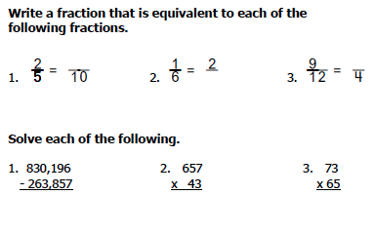

Add/Sub Fractions HW #1
TUESDAY
Directions: Find the least common multiple and change the fractions to show common denominators. Do not solve the addition problems.
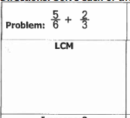
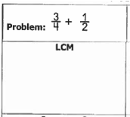

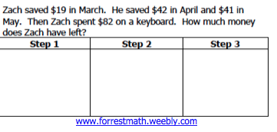
List the multiples for the following numbers:

3.
4

4.
7

WEDNESDAY
Directions: Find the least common multiple AND then change the fractions to show common denominators. Do not solve the subtraction problems.
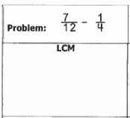
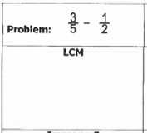

List the multiples for the following numbers:

3.
12

4.
9

Solve

Last week the economics fair was at Forrest. Tickets were $2 for kids and $3 for adults.

- 143 kids bought tickets
- 98 adults bought tickets

How much money did the second grade collect from ticket sales?
THURSDAY
Directions: Find the least common multiple AND then change the fractions to show common denominators. Do not solve the addition or subtraction problem.

Problem: 4% +2! )
LCM

Problem: 3* - 1#
LCM

3. How does finding least common multiple help you make common denominators?
________________________________________________________________________________________________________

4. Circle all of the multiples that 3 and 6 have in common.

2 3 5 6 9 12 14

18 21 24 28 30 33 36

Solve

I received $3,492 in my paycheck. After I pay $1,875 for my house and $552 for my car, do I have enough money to go on a weekend getaway that costs $925?

