Name ________________________________
MONDAY
*Unit 4 test on Friday 12/7*
Shade in all of the related facts for 9, 45, 5:

36 + 9 = 45 | 9 x 5 = 45 | 45 ÷ 5 = 9
5 x 8 = 40 | 45 ÷ 9 = 5 | 5 x 9 = 45

Shade in all of the related facts for 21, 3, 7:

21 ÷ 7 = 3 | 7 x 3 = 21 | 21 ÷ 3 = 4
3 x 7 = 21 | 21 ÷ 3 = 7 | 21 + 3 = 24
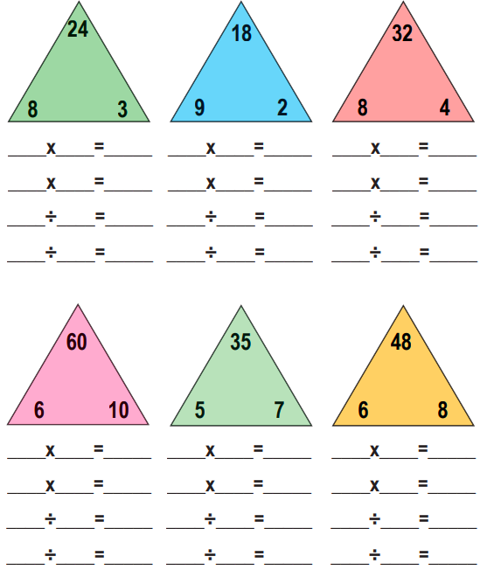

Unit 4 Review
TUESDAY
This is a 3-minute drill – practice at home. Can you complete these in 3 minutes?
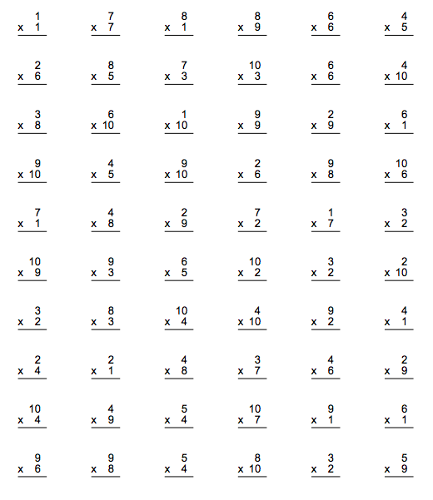

www.forrestmath.weebly.com
WEDNESDAY
Draw models to solve these 2x1 multiplication problems.

1) 33 x 4

2) 15 x 5

3) 81 x 3

4) 93 x 2

5) 57 x 4

THURSDAY
Answer the following using arrays, equal groups, or a number line.

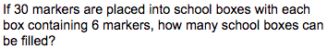
1)

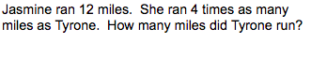
2)

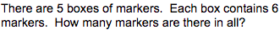
3)

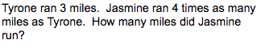
4)

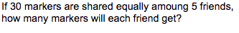
5)

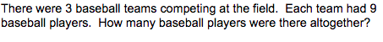
6)

