Name _______________________________________
TUESDAY
1. On Monday morning a baker was planning on baking bread. He finished making the dough and was ready to put it in the oven at 7:40 A.M. and it was fully heated at 11:40 A.M. How long did the oven take to heat?
______ hours

2. On Tuesday, Pedro, a zookeeper, began feeding the animals at the National Zoo. He started at 8:15 A.M. and finished the job at 12:15 P.M. If he didn’t take any breaks, how long did it take Pedro to feed the animals?
______ hours

Number 1 | Number 2
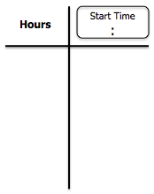

Review
3. Round the following to the nearest hundred and nearest thousand.
Number | Nearest  Hundred | Nearest  Thousand
5,483

4. Marcel went to a concert. There were 8,209 total people at the concert and 3,015 of those people were males. How many people were female?

Elapsed Time/Temperature HW

What is the temperature on the thermometers below?
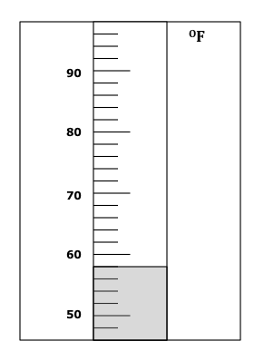
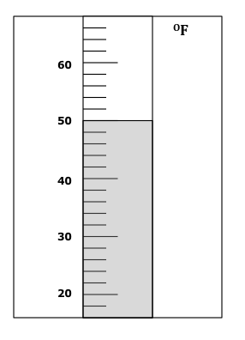
____ ^{O}C

____ ^{O}F

Review
Write the missing number.
Then write three related facts.

8 x 7 = _____ | 11 x 8 = _____ | 12 x 5 = _____
_____________  _____________  _____________ | ______________  ______________  ______________ | ______________  ______________  ______________

www.forrestmath.weebly.com
WEDNESDAY
1. Saturday afternoon, Lisa and her friend Penny went for a hike at 9:25 A.M. They returned home at 4:25 P.M. How long were they hiking?
______ hours

2. Mr. Anderson went to see a movie. The movie started at 4:20 P.M. When the movie was over, his watch read 6:30 P.M. How long did the movie last?
______ hours

Number 1 | Number 2
____ ^{O}C

____ ^{O}C

Review

Review
3- 4. Count each collection of coins. Write the value of each collection on the line underneath the collection.
Q dddD
nnppp

Q q nN n ddp

Value: _________ Value: _________

5. The sum of 6,235 + 4,681 is a little more than –
A 10,000 C 14,000
B 12,000 D 16,000

What is the temperature on the thermometers below?
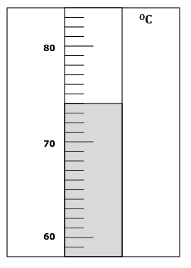
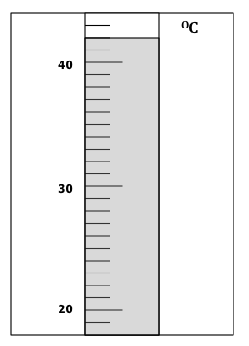

REVIEW

Solve the problem below.

Amanda likes to read at night. This week she read for three nights. She read for 30 minutes on Tuesday. On Wednesday she read for 45 minutes and on Thursday she read 25 minutes. How many minutes did Amanda read this week?

______ minutes

Name ________________________________
THURSDAY
1. Jason set out to run some errands. He left his house at 11:40 A.M. If he returned home at 3:40 P.M., how long was he out?
______ hours
2. Cassandra is making a cheesecake. She puts it in the oven at 1:26 P.M. and doesn’t take it out until 4:26P.M. How long did it take for the cheesecake to cook?
______ hours

Number 1 | Number 2

Review
Fill in the pattern boxes below.
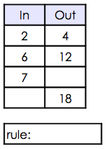
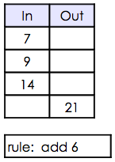
3. 4.

Shade the thermometer below to show 52^{O}F
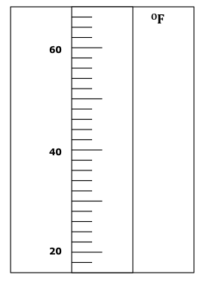

REVIEW
Solve the problems below.

35 x 4 = _______ 63 x 3 = _______

95 x 2 = _______ 56 x 5 = _______

www.forrestmath.weebly.com

