Name ________________________________
TUESDAY – Money Review

1. Casey and Tony opened their piggy banks.
- Casey has 6 dimes, 3 nickels and 1 quarter.
- Tony has 7 dimes, 5 nickels, and 2 quarters.

What is the value of Casey’s collection of coins? ___________
What is the value of Tony’s collection of coins? ____________
Who has the collection of coins with the LARGEST value?
______________

Problem  Megan bought a hamburger and fries for dinner. Her dinner cost $2.46. She gives the cashier $5.00. How much change will Megan receive? | Show your answer here using coins and bills. | Show your answer here using subtraction
2. Which child has the most money?
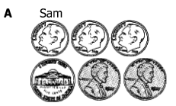
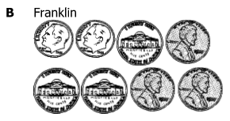

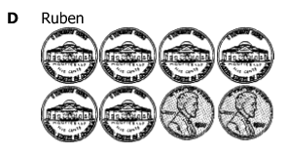
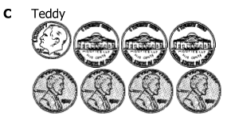

SOL Review HW #3
WEDNESDAY – Graphing Review
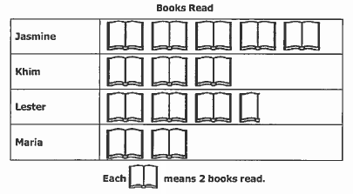

1. How many books did Jasmine and Khim read together? _________
2. How many more books did Jasmine and Khim read than Lester and Maria combined? __________
3. How many books were read by all four of these students? ___________

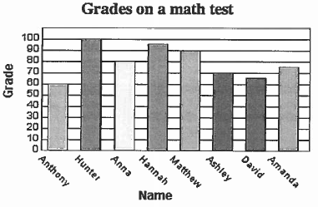

1. What scores did Hannah receive on her test? _________________
2. How much higher did Matthew score than David? _______________
3. What is the combined score for Anthony, Hunter, and Ashley?
________
THURSDAY – Probability Review

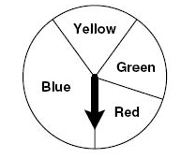
1. Which color is the spinner MOST LIKELY to land on?
How do you know?

________________________________________________

2. Reed has to choose from these hats and shirts
for a costume. How many different combinations of one hat and one shirt can Reed make?
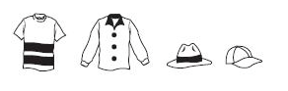

3. If the following marbles were in a baggie and you pulled one
out without looking, what is the probability that you would pull
out:
a) light marble = _________________

b) dark marble = _________________

c) a striped marble = ______________

d) a round marble = _______________

4. Which statement is the best definition of the word probability?

A) Probability means that all events are certain to happen.
B) Probability is the chance that an event will happen.
C) Probability means that you will spin a spinner or roll a number cube.
D) Probability means that you can only have one possible outcome for an event.

www.forrestmath.weebly.com
1. Corey bought a toy that cost $3.52. If he gives the cashier a $5 dollar bill, how much change should he get back?

A) 3 dollars, 2 quarters, 2 pennies

B) 2 dollars, 3 quarters, 8 pennies

C) 1 dollar, 5 dimes, 8 pennies

D) 1 dollar, 1 quarter, 2 dimes, 3 pennies

4. You have a box of chocolate candy with ten pieces.

• Three have raspberry filling
• One has cherry filling
• Six have peanut butter filling

What are the chances that you will pick a cherry filled candy?

A) impossible B) unlikely

C) likely D) certain

