Name _________________________________
MONDAY – Multiplication Review

Part I: Complete the following patterns using skip counting.

4, 8, 12, ___, ____, ____, ____, ____, ____

6, 12, 18, ___, ____, ____, ____, ____, ____

7, 14, 21, ___, ____, ____, ____, ____, ____

8, 16, 24, ___, ____, ____, ____, ____, ____

9, 18, 27, ___, ____, ____, ____, ____, ____

Part II: Solve the following

7. 45 8. 93 9. 37
x 8 x 6 x 4

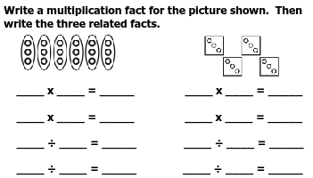

SOL Review HW #2
TUESDAY – Temperature Review

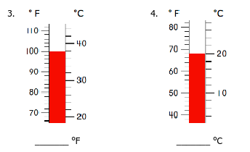

Shade the thermometers below

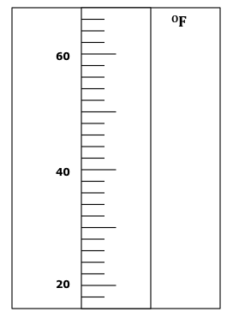
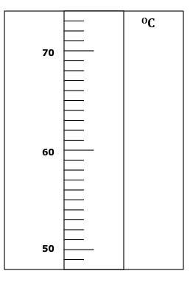
Shade 56^{O}C Shade 32 ^{O}F

When reading a thermometer, I need to know that they can count by ones, but they can also count by: ________. _________, or __________.

WEDNESDAY – Area and Perimeter
Part I: Define both area and perimeter.

Perimeter - ___________________________________

Area - _______________________________________

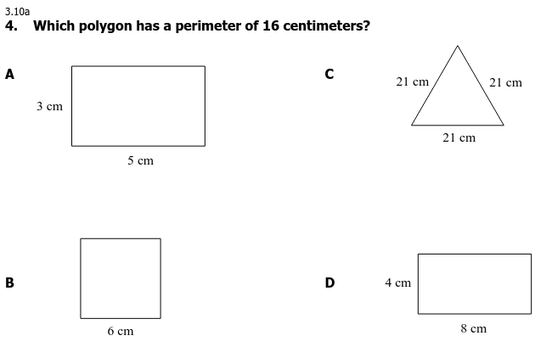
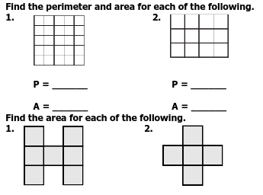
A = _______ A = _______

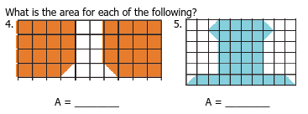
www.forrestmath.weebly.com
THURSDAY - Test Practice

1. Karla decided to give whistles to all the guests at her party. She bought 6 bags that had 3 whistles each. How many whistles did Karla buy?

2. Brandy bought marbles for her marble collection. Each bag had 8 marbles in it. Brandy bought 5 bags of marbles. How many marbles did Brandy buy?
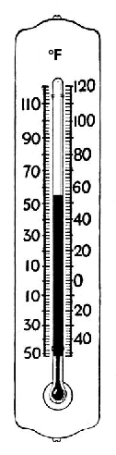

A 50º F

B 55º F

C 60º F

D 65º F

