Name _______________________________________
MONDAY
Part I: Parts of a bar graph
Directions: label the parts of a bar graph on the graph shown below. Be sure to use arrows to indicate what you are labeling.

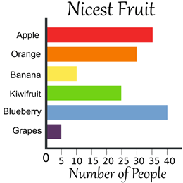

Part II: Analyzing a bar graph.

1) Analyze means to __________________________.
2) This bar graph is: horizontal or vertical

3) What survey question could have been asked to generate this data?
__________________________________________________________________________________________________________
4) What is the scale counting by? ______________

5) How many people liked blueberry more than banana? ___________

6) Which two fruits combined were nicest?
banana/kiwifruit or blueberry/grapes

7) Which two fruits combined total fifteen? __________ and __________

www.forrestmath.weebly.com
Picture Graph HW
TUESDAY
Part I: Vocabulary

horizontally vertically data survey key picture graph

1) The ___________ lets you know what each picture equals (what you are counting by).

2) A _______________________ displays data using pictures.

3) You can collect data to display in a graph by conducting a
_________________.

4) Information collected in a survey and then displayed in a graph is called
_________________.

5) Data in a graph can be displayed ___________________ or across.

6) Data in a graph can be displayed ___________________ or up and down.
Part II: Analyzing (understanding) a picture graph.
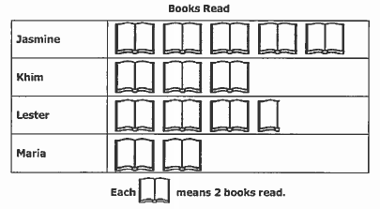

1. How many books did Jasmine and Khim read together? _________

2. How many more books did Jasmine and Khim read than Lester and Maria combined? __________

3. How many books were read by all four of these students? ___________
WEDNESDAY
Part I: Parts of a picture graph

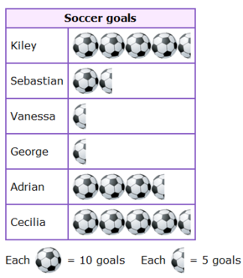

1) Circle the title of the graph
2) Put a box around the key
3) Shade in the data
4) What does half of a soccer ball mean? __________

Part II: Analyzing (understanding) a picture graph
Directions: Using the graph above, answer the following questions using true (T) or false (F).

5) Each soccer ball picture equals one goal ______
6) Sebastian scored six goals ______
7) Vanessa and George scored ten goals each ______
8) Cecilia scored the most goals ______
9) Adrian scored 35 goals ______
10) Sebastian scored ten more goals than George ______

www.forrestmath.weebly.com
THURSDAY
Part I: Creating a picture graph
Directions: Using the information from the table, create a picture graph to show the data collected. Be sure to include the following parts of a picture graph: title, labels, pictures (data), key, and categories.

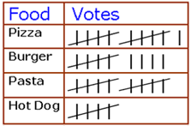
*Use a heart to show the data*

