Name _______________________________________
MONDAY
Write the multiplication sentence represented.
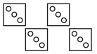
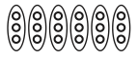
1. 2.

____ groups of _____ ____ groups of _____

_____ x _____ = _____ _____ x _____ = _____

3. 4.

____ groups of _____ ____ groups of _____

_____ x _____ = _____ _____ x _____ = _____

Review
Round the following to the nearest hundred and nearest thousand.

Number | Nearest  Hundred | Nearest  Thousand
6,487

Number | Nearest  Hundred | Nearest  Thousand
7,234

www.forrestmath.weebly.com
Multiplication HW
TUESDAY
Draw an array to represent the facts below.
1. 2.
3 x 6 = _____
5 x 3= _____

Review

Solve.

3. 8,456 + 6,538 = _____

4. 5,634 – 3,493 = _____

5. 4,760 – 3,289 = _____

6. Ms. Parker worked the concession stand at her son’s baseball game. They sold 368 hot dogs and 232 boxes of popcorn. About how many more hot dogs were sold than boxes of popcorn?

WEDNESDAY
Draw equal groups to represent the facts below.
3. 4.
3 x 8 = _____
4 x 7= _____

Draw an array to represent the facts below.
3. 4.
6 x 7 = _____
3 x 2 = _____

Review

Circle all of the numbers that round to 3,000.

2,499 3,399 3,092 1,399

2,712 3,951 2,199 2,834

3,567 2, 513 3,709 3,289

www.forrestmath.weebly.com
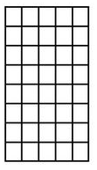
THURSDAY

1. 2.

_____ rows of _____ ____ rows of _____

_____ x _____ = _____ _____ x _____ = _____

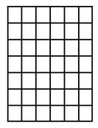
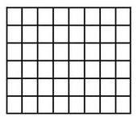
3. 4.

_____ rows of _____ ____ rows of _____

_____ x _____ = _____ _____ x _____ = _____

Review

Maria has spent 1,054 days in school since kindergarten. Her little brother has spent 716 days in school. How many more days has Maria spent in school than her brother?

