Name _______________________________________ Counting and Comparing Money HW
MONDAY
Write the value of the coins below: Draw the coins in order from least to greatest. Then count.
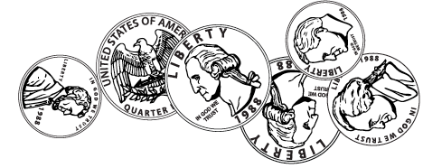
1.
Work Space

______ ¢ OR $_____.______

2. Write the value of the coins below: Draw the coins in order from least to greatest. Then count.
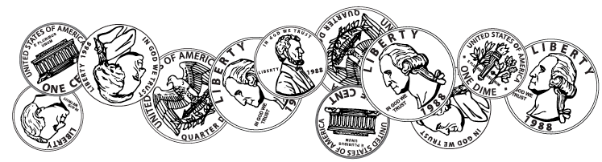
Work Space

______ ¢ OR $_____.______

Review
3. Ms. Parker is baking three types of cookies for a bake sale. She needs to bake a total of 150 cookies. She baked 43 chocolate chip cookies and 39 peanut butter cookies. The rest of the cookies will be sugar cookies. How many sugar cookies will Ms. Parker need to cook?

4. Mrs. Ralls is baking cookies for the same bake sale as Ms. Parker. Mrs. Ralls has to bake 125 total cookies. She baked 64 cookies Saturday and 32 cookies on Sunday. Mr. Ralls tasted the batch on Sunday and they were so good he ate 12 of them! How many cookies does Mrs. Ralls have left to bake?

Forrestmath.weebly.com Twitter @forrestmath1406
TUESDAY
1. Write the value of the coins below: Draw the coins in order from least to greatest. Then count.
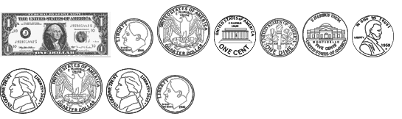
Work Space

$_____.______

2. Write the value of the coins below: Draw the coins in order from least to greatest. Then count.
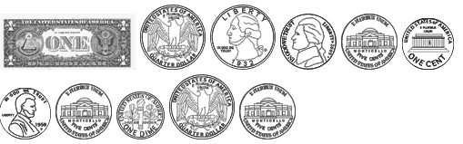
Work Space

Review
3. Timothy is reading a book that has 272 pages. He read 79 pages on Saturday and 37 on Sunday. If he reads 51 pages, how many pages will he have left to read?

4. Blake collects baseball cards. He had 178 baseball cards. He received a pack of ten cards for his birthday. His friend Grant is starting a collection and Blake gave him 39 to help get him started. How many baseball cards does Blake have now?

