**Name _______________________________________**

**MONDAY**

**Use a ruler to measure the length of the line segment below.**

**The length of the line segment to the nearest inch is about -**

**_______ inches**

**The lengths of the objects below is about:**

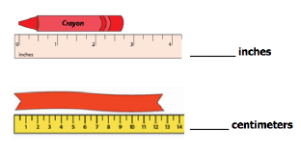

**Review**

**4.** 5 8 **5.** 7 1  **6.** 6 2 + 2 5 - 4 9 - 3 7

**4.** 6 7 8 **5.** 4 1 8

+ 1 2 5 - 4 9 2

[www.forrestmath.weebly.com](http://www.forrestmath.weebly.com)

**Measuring Length HW**

**TUESDAY**

**Use a ruler to solve the problem below.**

**What is the length of the butterfly’s wingspan to the nearest half inch?**

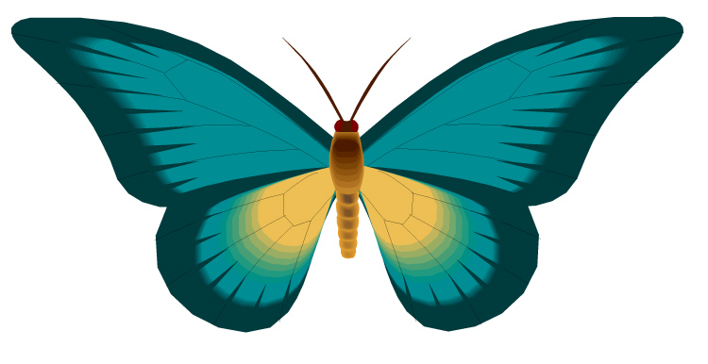 **A** 2



**B** 2

**C** 6



**D** 6

**The length of the rectangle below is about: ________**

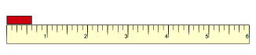

**Review**

**1.** 4 2 **2.** 7 7  **3.** 4 8 + 3 3 - 4 6 - 2 7

**4.** 4 7 **5.** 8 0  **6.** 7 1 + 2 6 - 5 6 - 4 8

**WEDNESDAY**

**Use a ruler to solve the problem below.**

**Which is closest to the length of the ant pictured?**

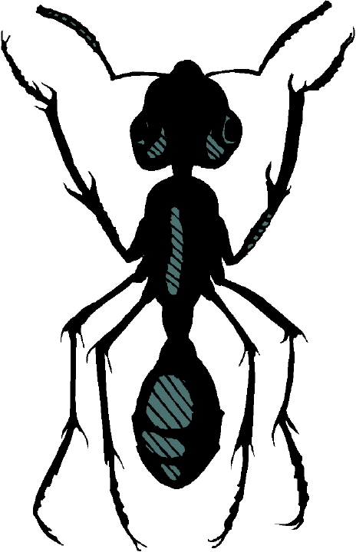**A** 1 centimeter



**B**  1 centimeters

**C** 2 centimeters



**D** 2 centimeters

**Use your ruler to draw lines the following lengths:**

**7 cm**

**4 ½ in**

**3 ½ cm**

**6 in**

**Review**

**Write the missing number.**

**Then write a related subtraction fact.**

|  |  |  |
| --- | --- | --- |
| **9 + 8 = _____** | **12 + 4 = _____** | **8 + 7 = _____** |
| **______________** | **______________** | **______________** |

**THURSDAY**

**Use a ruler to solve the problem below.**

**What is the length of this object in centimeters? Inches?**



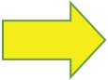

**________ centimeters __________ inches**

**Review**

**1.** 5 3 4 2 **2.** 9 0 1 7

- 4 8 1 4 - 4 3 2 2

**3.** 2 7 0 7 **4.** 6 0 0 0

+ 2 6 9 6 - 3 3 6 6

[www.forrestmath.weebly.com](http://www.forrestmath.weebly.com)