Name _______________________________________
WEDNESDAY
Directions: Solve each of the following.
1. 5^ - 3^ 2. 1$ + 1$ 3. 2% + 1%
t
f
y

1. 2# - 1# 2. 2^ + 3^ 3. 1! ) + 4! )
K
Y
d

Review
Directions: Write a mixed number for the models below.
1. 2.

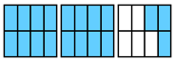
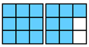
3. 4.

5. Eric bought a bike that cost $240 and a washing machine for $395. If Eric had $1000 saved, how much money does he have left after his purchases? (2 steps!)

www.forrestmath.weebly.com

Add/Sub Fractions HW
THURSDAY
g - d
Directions: Solve each of the following.
1.
=

C + B
2.

=

R + R

3.
=

Review
Derek had 45 games. He gave 14 games to his friend, Steve. Then Derek got 13 more games for his birthday. How many games does Derek have now? (2 steps!)

1. What is the total number of hours in exactly 1 day? _______

2. How many minutes are equal to two hours? _____________

3. Ginger wore braces for exactly 1 year. How many days did

she wear braces in all? _____________

4. About how many days are in one month? _______________
Name _____________________________________
MONDAY
Directions: Use the grid paper below to change the following
improper fractions into mixed numbers.

1) 1 3* 2) 7% 3) 1 1^

Review
Directions: Shade thermometer A to show 64^{O}C, shade
thermometer B to show 52^{O}F.

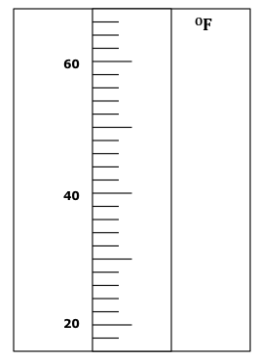
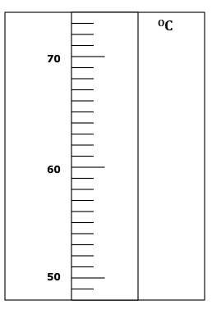
A) B)

Review HW
TUESDAY
Directions: decide if fractions are greater than, less than, or
equal to half.

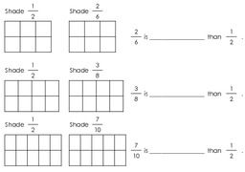

Review
