WEDNESDAY
Part I: Describe what congruent means.

Congruent means ______________________________
____________________________________________

Part II: Identifying congruent shapes

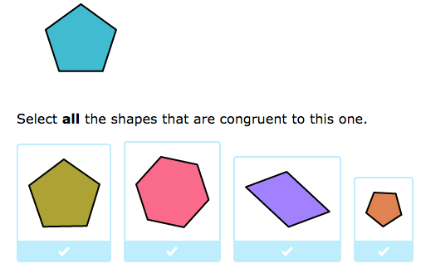
1.

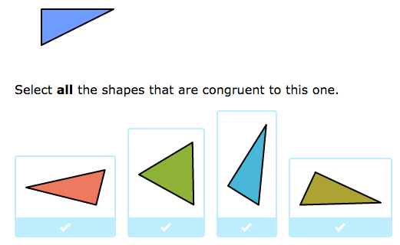
2.

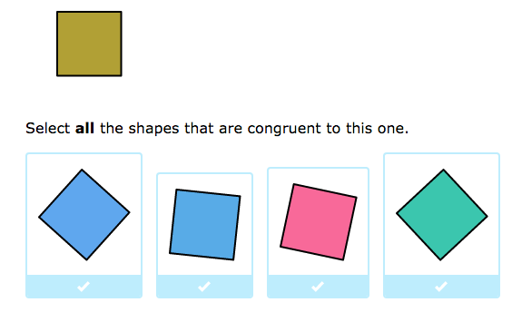
3.

THURSDAY
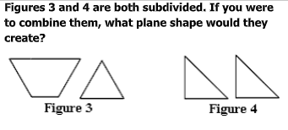
1.

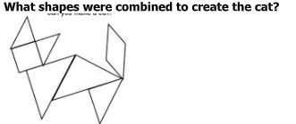
2.

Review – 2x1 multiplication

3) 57 x 3 =

4) 88 x 2 =

5) 23 x 5 =

6) 61 x 4 =

www.forrestmath.weebly.com
Name ________________________________
MONDAY
Part I: Geometry “Who am I?”

1. I have four equal sides and four right angles.
______________________

2. My opposite sides are parallel and congruent. I also have four right angles. _______________________________

3. I have three sides and three angles ___________________

Part II: Creating geometric figures

4. Draw and label the figure that has one endpoint and extends in the other direction forever.

5. Draw and label the figure that is an exact point in space.

6. Draw and label the figure that extends in both directions forever.

Geometry Review HW
TUESDAY
