**Name _________________________________**

**MONDAY**

**Part I: Write what fraction of each shape is shaded.**

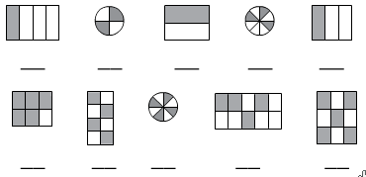

**Part II: Shade the figures to show the fraction below it.**

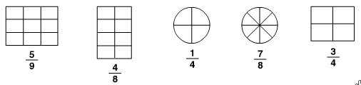

**Part III: Shade the figures to show the fraction below it.**

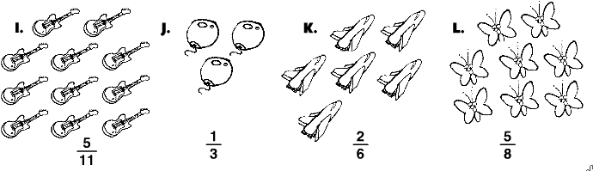

**Part IV (Review) Round each of the following to the place value below the number.**

**6,206 4,825 7,099 hundreds place thousands place tens place**

__________ __________ _________

**Fractions HW**

**TUESDAY**

**Part I: A fraction model is drawn inside each box. Name the fractional part that is shaded.**

EightTenths



**Fraction: _________ Fraction: _________**

**Part II: Shade each model to represent the fraction or mixed number written below each box.**

" " " "

**Fraction: Fraction:**

one and two fourthsthree and two tenths

iii

iii

**Fraction:**

two and five eights

**Review**

**Write the time shown on each of the clocks.**

awQ awR a

h h h

**WEDNESDAY**