Name _______________________________________
MONDAY
Write what fraction is shaded below each model. Then use >, <, or = to make a true statement.
1. 2.

3. 4.

Review
1. Ms. Wilson bought tickets for her vacation. She paid $380 for water park tickets and $520 for concert tickets. What is the best estimate for the total amount she spent on tickets?

2. Devin wants to buy a new video game that costs $57. If he received $10 for mowing the lawn and $18 for raking leaves, how much more does Devin need to save before he has enough to buy the video game?

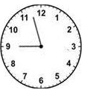
Write the time shown on each clock below
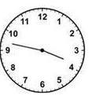
3. 4.

_____ : ______ _____ : ______
Comparing Fractions HW
TUESDAY
Shade the model to show the fraction below it. Then use >, < , or = to make a true statement.
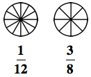
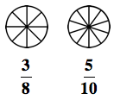
1. 2.

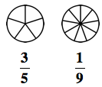
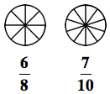
3. 4.

Review
1. Estimate the difference first, then find the actual difference.
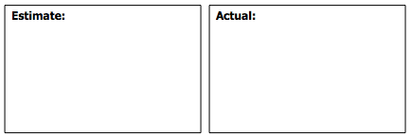
9,053 – 3,749 =

2. Round each of the following to the nearest hundred and thousand.
Number | Nearest Hundred | Nearest Thousand
6,284

3,861

WEDNESDAY
Shade the fraction to show the number written below it. Then use >, <, or = to make a true statement.
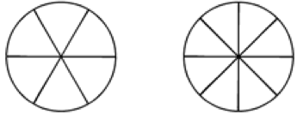
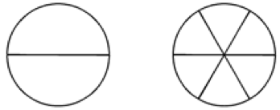
1. 2.

4^
1@

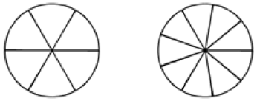
3. 4.

55(
5^

Review
Solve each of the following.
5. 78 6. 59 7. 43
x 3 x 5 x 4

8. Jayla was making bracelets for eight of her friends. She used 25 beads for each bracelet. How many beads will she need in all?

9. Daniyah had 72 pieces of candy to share with her friends. If she gave an equal amount to nine friends, how many pieces of candy did each friend get?

www.forrestmath.weebly.com
THURSDAY
Write the fraction shaded next to each model. Then use >, < or = to make a true statement.
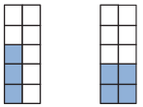
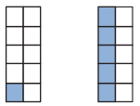
1. 2.

5*
2^

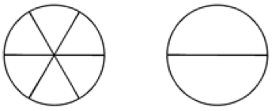
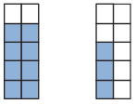
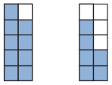
3. 4.

1@
2^

Review
5. Circle all of the statements below that are true.

4 + 7 = 3 x 11 5 x 6 = 15 + 15 10 x 2 = 10 + 10

7 x 3 = 10 + 11 8 + 9 = 14 + 4 12 – 4 = 4 x 2

Write the mixed number represented by each of the following.
6.

___________

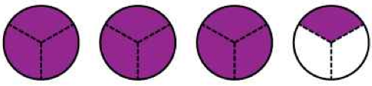
7.

___________

