Name ________________________________
MONDAY
Part I: Complete the multiplication chart below
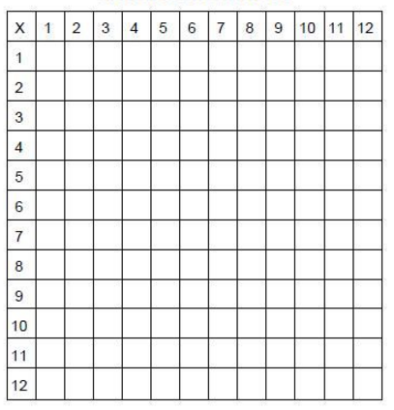

Part II: Use rounding to fill in the chart below.

NUMBER | Nearest thousand | Nearest hundred
5,394

998

3,217

Multiplication HW
TUESDAY
Part I: Multiply with Models
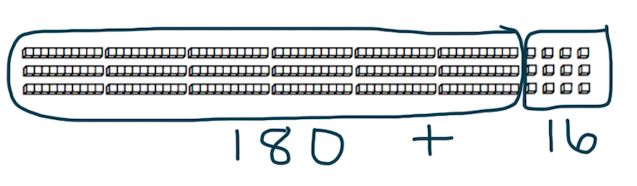
⁺¹
Ex. 6 4
x 3
192

64 x 3 = 192 is actually 60+60+60=180 plus 4+4+4=12. Notice you calculate the same product! Try it! Draw the models below.

1) 5 2
x 4

2) 7 1
x 5

Part II: Review the Following

4. 8,021 5. 5,002
+ 6,239 - 5,916

6. 21 ~ 3 = ______ 7. 54 ~ 6 = _____

www.forrestmath.weebly.com
WEDNESDAY
Part I: Solve the following by drawing place value models.

1) 49 2) 33 3) 71
x 2 x 4 x 3

Part II: Review

Use >, <, or = to make a true statement.

4,136 _______ 4,163 3,014 _______ 3,140

1,703 _______ 1,703 2,856 _______ 2,865

Circle all of the numbers that will round to 7,000.

7,451 6,601 7,953

6,417 7,132 6,541

1. 5, 6 3 7 2. 8, 4 2 0
+ 4, 6 8 2 - 5, 4 7 6

THURSDAY

1. Daniel’s school held a food drive. Daniel was given the task of putting 39 canned goods in 5 baskets. How many canned goods did Daniel’s school collect in all?
________

2. A party planner put 4 plates on each table at Monique’s birthday party. There are 64 tables set up at the party. How many people did the party planner expect to be at the party?

A) 60 B) 68 C) 246 D) 256

3) Vera's sticker collection fills 3 pages in her sticker book. There are 22 stickers on each page. How many stickers are in Vera's collection?
_______

4) Fudge from Tim's Sweet Treats costs $18 per pound. How much does 4 pounds of fudge cost?

A) $22 B) $12 C) $72 D) $42

www.forrestmath.weebly.com

