Name _______________________________________
UNIT 4 TEST ON FRIDAY 12/7
MONDAY
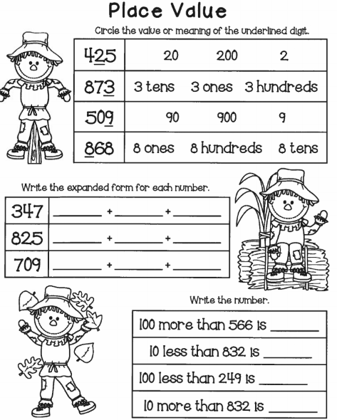

www.forrestmath.weebly.com
Unit 4 Review HW
TUESDAY
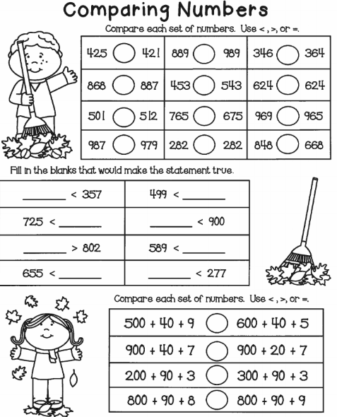

WEDNESDAY

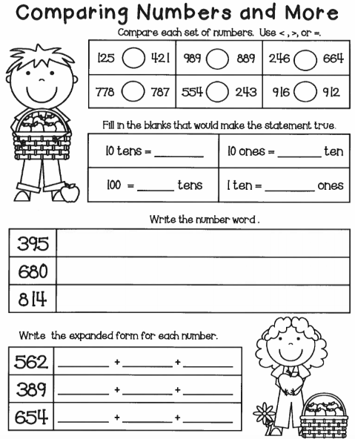

THURSDAY

Rounding
Shade all of the numbers that will round to 80 when rounding to the nearest ten.

77 | 84 | 86
75 | 81 | 73
Use the number lines below to round the following numbers to the nearest ten.

14
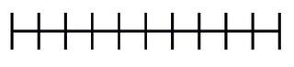

38

96

When rounded to the nearest ten, which of the following numbers will round to 30?

A) 21 B) 24 C) 28 D) 35

When rounded to the nearest ten, which of the following numbers will round to 100?

A) 10 B) 93 C) 94 D) 95

