Name ________________________________
MONDAY
Tell the time on each clock to the nearest 5 minute.
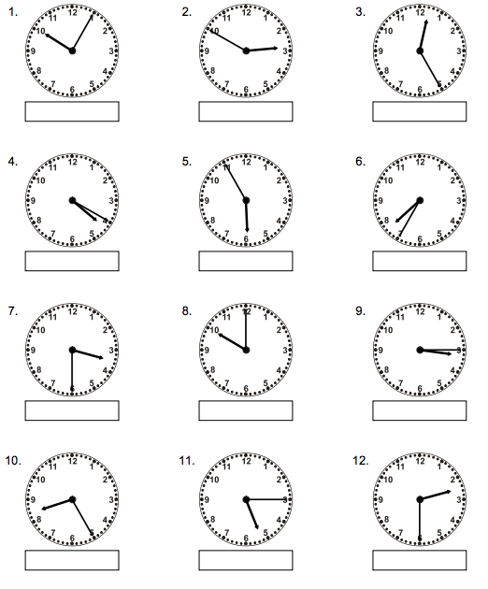

Review – Add

13) 45 + 31 14) 83 + 38 15) 77 + 24

Telling Time #2
TUESDAY
Show the time on each clock.
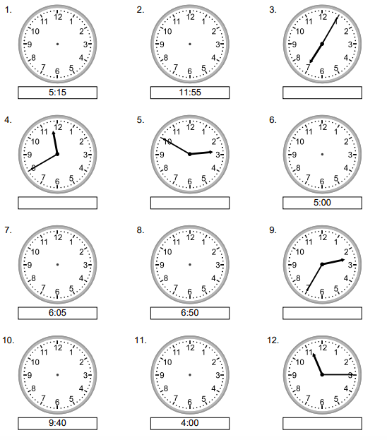

Review – Subtract

13) 45 – 31 14) 83 – 38 15) 77 – 24

www.forrestmath.weebly.com
WEDNESDAY
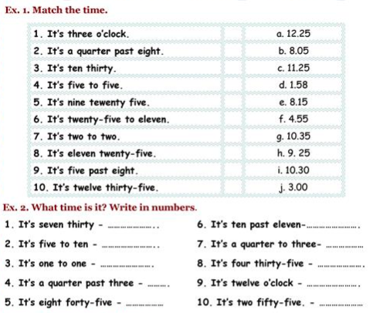

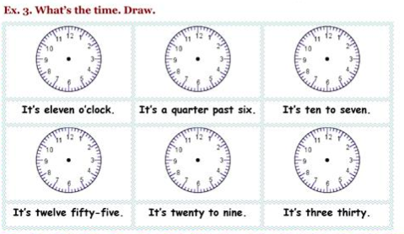

THURSDAY
Answer the following question about time:
