Name _________________________________
MONDAY
Part I: Explain how you can tell if an object has symmetry.

An object has symmetry when ___________________________

____________________________________________________

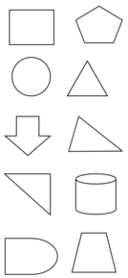
Part II: The following shapes have symmetry. Draw the line(s) of symmetry for each shape. Some shapes have more than one line of symmetry.

Symmetry HW
TUESDAY
Part I: Complete each monster so that they are symmetrical

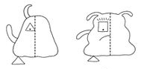

Part II: How many letters have symmetry? Circle them and draw the line(s) of symmetry.
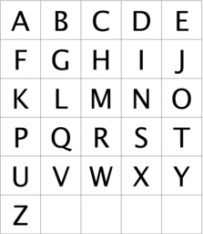
www.forrestmath.weebly.com
WEDNESDAY
Part I: Complete each monster so that they are NOT symmetrical.
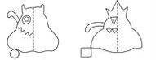

Part II: in the boxes provided, draw four figures that have at least one line of symmetry.

THURSDAY – Test Practice

1. Look at the square below.

How many lines of symmetry can be drawn in this square?

F one H three
G two J four

2. Bill drew four examples to show lines of symmetry for a circle. Which of the following is NOT correct?

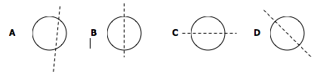

3. Circle the shapes that have EXACTLY one line of symmetry?

4. Which of the following statements is TRUE?

A a line of symmetry can curve to divide the shape into two parts
B a line of symmetry divides a shape into two parts of different sizes
C a line of symmetry divides a shape into two parts that match exactly
D a line of symmetry divides a shape into two parts that
almost match

www.forrestmath.weebly.com

