Name _________________________________
MONDAY
Use the place value blocks to find the difference between the two numbers.

1)
ppppppppg – ppppl = ______

2)
pppppppppg - ppppppppl =_____

3)
ppppn - pp m = ______

4)
pppppp, - ppppc = ______

5)
]ppg - ]ppd = _____

Subtraction Review HW
TUESDAY
Answer the following.

1) Dawn wanted to estimate the difference: 68 – 17 =
Which numbers should she use?

A 60 – 17 C 70 – 20
B 60 – 20 D 60 – 10

2) If I wanted to estimate the difference of 34 – 12, which numbers should I use?

A 30 – 15 C 35 – 10
B 30 – 10 D 40 – 20

3) Mrs. Rancorn said to estimate the difference of 91 and 76. Which numbers does she want me to use? Write them below.

_______ and _______

Find the estimated difference of the following:

4) 6 4 5) 7 8 6) 9 3
- 3 1 - 5 7 - 4 6

www.forrestmath.weebly.com
WEDNESDAY
Find both the estimated and actual answers to the following problems.

1) 7 6 2) 6 8
- 3 4 - 3 9

3) 5 2 4) 9 0
- 1 3 - 4 1

Read through, visualize, and solve the following word problems involving subtraction.

5) Noah was reading a story with Mrs. Tester. The first time he read it, it took him 73 seconds. The second time he read the story it took him 41 seconds. By how much did his second time improve over his first time?

6) Kristen saw a candy bar at the store that she really wanted so she used 3 quarters to buy it. The candy bar cost 53 cents. How much change did Kristen receive?

THURSDAY
Tomorrow you have a unit test on subtraction, practice answering the following “test” questions.

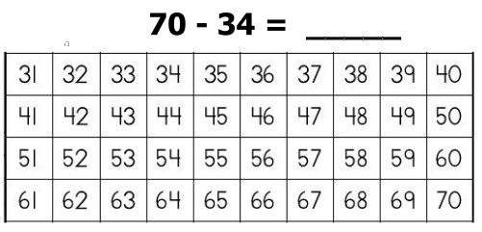
1) Use the 100’s chart to subtract the following.

2) What subtraction fact goes in the blank to make a true statement?
37 = ______________

A) 52 – 15 B) 59 – 25
C) 57 – 20 D) 63 – 26

3) Haley is a superhero. Last week, she rescued a total of 52 people from danger. If Haley rescued 39 children, how many adults did she rescue?
________

4) Tony is a school janitor. Last week, he picked up a total of 31 pieces of trash. If he picked up 17 pieces of trash in the classrooms, how many pieces of trash did Tony pick up outside the classrooms?

________

