Name __________________________________
MONDAY
Part I: Solve the following subtraction problems.

1) 19 – 9 = _______ 2) 16 – 7 = _______

3) 27 – 20 = ______ 4) 14 – 5 = _______

5) 21 – 8 = ______ 6) 17 – 3 = _______

Part II: Solve the following subtraction problems by regrouping.

7) 7 6 8) 3 0 9) 5 3
- 2 9 - 1 5 - 3 7

Part III: Solve the following subtraction problems by regrouping.

7) pPPPPK – PP l =

8) ppppppps – ppppm =

Subtraction/Money Review HW
TUESDAY
Part I: Answer the following questions. Draw the coins.

1) Amanda went to the store with: 5 pennies, 3 dimes, 2 nickels, and 1 quarter. Does she have enough money to get an ice cream cone that costs 70c? How do you know?

2) Leo got $0.62 change from the cafeteria. He received 1 quarter, 3 dimes, 1 nickel, and 2 pennies. Did he receive the correct change? How do you know?

Part II: Shade in all of the sets of coins that are greater than 50c

dNnnPppppp
qnnNppp
nnnnddppppppppp
qqpppp

www.forrestmath.weebly.com
WEDNESDAY
Part I: Solve each of the following.

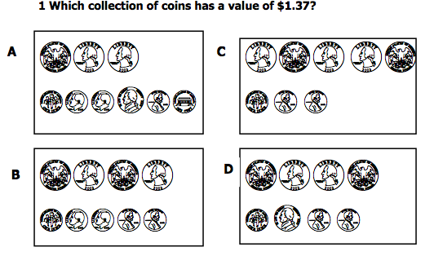

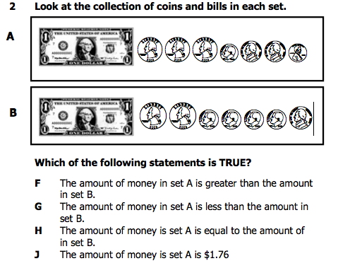

THURSDAY
Read through, visualize, and solve the following word problems involving subtraction.

1) Sidney held a garage sale and sold a combined total of 77 toys and books. She sold 69 toys. How many books did she sell?

2) Mrs. McKnight is buying gifts for her son and daughter. So far, she has bought a total of 34 gifts. 15 of the gifts are for her son. How many of the gifts are for her daughter?

3) Last year, Mitchell's cats caught a total of 91 mice and birds. His cats caught 72 mice. How many birds did Mitchell's cats catch last year?

Part III: Review: What time is shown on the clocks below?
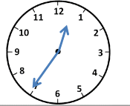
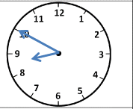

4) 5)

