Name _________________________________
MONDAY
Shade the chart to show skip counting by 2’s – use a color if you have one!

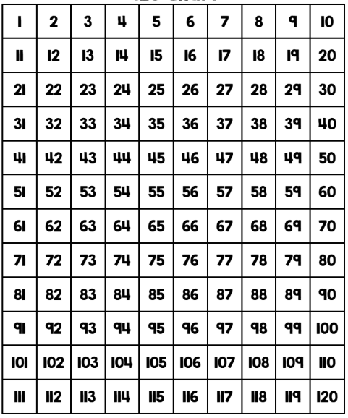

www.forrestmath.weebly.com

Skip Counting HW
TUESDAY
Shade the chart to show skip counting by 10’s – use a color if you have one!
What do you notice about the numbers you shaded?
____________________________________________

____________________________________________
WEDNESDAY
Shade the chart to show skip counting by 5’s – use a color if you have one!
What do you notice about the numbers you shaded?
____________________________________________

___________________________________________

THURSDAY
Directions: skip count by 2, 5, or 10.

1) Starting at the number fourteen, skip count by two.

______, ______, ______, ______, ______, ______, ______

2) Starting at the number 35, skip count by five.

______, ______, ______, ______, ______, ______, ______

3) Starting at the number twenty, skip count by ten.

______, ______, ______, ______, ______, ______, ______

Shade the sets of numbers that are NOT correctly counting by 2’s:

4 6 8 10 12 15 18 20
64 66 68 70 72 74 76 78
20 25 30 35 40 45 50 55
70 72 74 76 78 80 82 84

Review
write a fact family below using the numbers: 7 12 19

www.forrestmath.weebly.com

