Name _________________________________
MONDAY

Part I: Use the number lines to help round the following numbers to the nearest TEN.
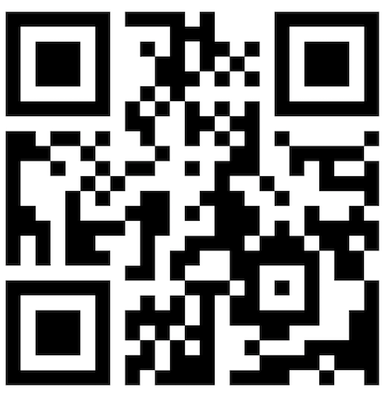
72 round to _______

39 rounds to ________

65 rounds to ________

14 rounds to ________

Part II preview: Circle all of the TRUE statements

45 > 33 29 = 29 86 < 76

One hundred thirteen is less than One hundred thirty-one

Nine hundred twenty-seven is equal to nine two seventy
Rounding HW
TUESDAY

Part I: In your own words, explain how you would round the number 33 to the nearest ten:
________________________________________________________________________________________________________________________________________________________________________________

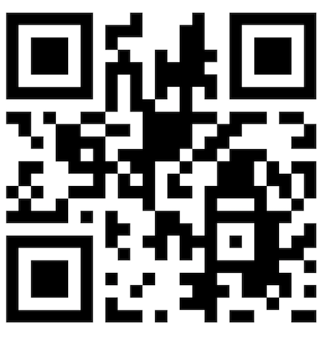
Part II: Round the following numbers to the nearest TEN

9 rounds to _______ 54 rounds to ________

31 rounds to _______ 98 rounds to ________

75 rounds to ________ 13 rounds to ________

Part III Review: Write the standard (number) form for each of the following.

sixteen ____________

twenty-one ____________

nineteen ___________

seven _____________

eighteen ______________

www.forrestmath.weebly.com
WEDNESDAY

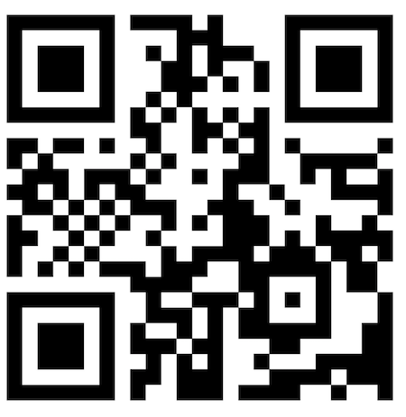
Part I: Circle the numbers that will round to 60 when rounding to the nearest ten.

54 59 65

63 49 72

Beth read 78 pages in her new book. Round 78
to the nearest ten.

F 50
G 60
H 70
J 80

Part II Place Value Review

What is the value of the “3” in 436?

F 3
G 30
H 36
J 300

Beth counted 678 beans in a jar. How many tens
are in 678?

_________

THURSDAY

Part I: Circle the numbers that do NOT round to 20 when rounding to the nearest ten.

11 25 23

16 21 14

Ms. Lavoie earned $43 dollars babysitting. Round 43 to the nearest ten.

Part II Review – Circle the correct related facts

5 + 6 = 11 3 + 12 = 15 14 + 4 = 18
6 + 5 = 11 12 + 3 = 15 9 + 9 = 18
11 – 6 = 5 15 – 3 = 12 18 – 14 = 4
11 + 6 = 17 15 – 12 = 3 18 – 4 = 14

What number is represented by the model below?
pdd ______

