Name _________________________________
MONDAY

What is probability? ___________________________________
____________________________________________________
Part I: Probability with a spinner
1. If you were to play a game using the spinner below, where could the spinner land?
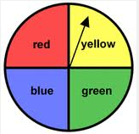
a) red
b) red or yellow
c) red, yellow, or blue
d) red, yellow, blue, or green

2. If you were to play a game using the spinner below, would you say that the spinner was fair? Why or why not?
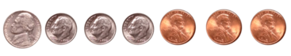
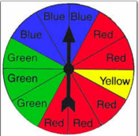
____________________________________________________________________________________________________________

3. What is the chance that the spinner would land on green?

a) 3 out of 3 b) 3 out of 12

c) 12 out of 3 c) 6 out of 12

What is the chance that the spinner will land on red? ________

www.forrestmath.weebly.com
Predicting Outcomes/Probability
TUESDAY
Part I: Probability with a coin.

1. If you chose a coin and flipped it, what could the coin land on? _____________________________

2. Choose a coin and flip it 100 times. Record the results using tally marks in the chart below.

Heads
Tails
How many times did your coin land on heads? ________

How many times did your coin land on tails? ________

Is the sum of the two outcomes 100? _________

Part II: Review of counting coins
Count the sets of coins below. Which set of coins is the most? Which set of coins is the least?
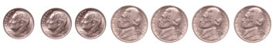
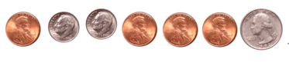

WEDNESDAY
Part I: Probability with items.

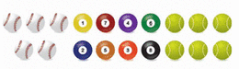
1. Ms. Hamilton was sorting out the sports equipment below

If Ms. Hamilton were to reach into her equipment bag and pull out a ball at random, list the probability that she would pull out:

A ball – __________ A pool ball - __________

A baseball - _________ A tennis ball - __________

2. Make a tally chart of the fruits shown below
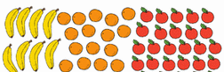

Bananas
Oranges
Apples
Without looking, what is the probability that the grocer would choose:

A piece of fruit - _________ A banana - _________

An orange - _________ An apple - _________

THURSDAY
Part I: Review the following bar graphs.
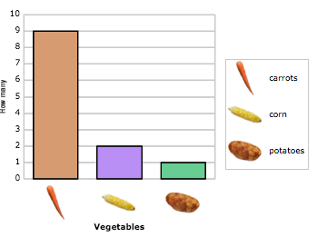
1. How many more carrots were there than potatoes?
_______

2. How many vegetables were there altogether?
_______

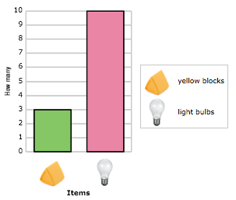
3. What is the difference between the number of yellow blocks compared to the number of light bulbs? _________

4. Is there a better chance of choosing a yellow block or a light bulb?
_________

