Name _________________________________
MONDAY
Part I: Solve the following subtraction problems by regrouping.

1) pPPPPK – PP l =

2) ppppppps – ppppm =

Part II: Read through, visualize, and solve the following word problems involving subtraction.

3) Noah was reading a story with Mrs. Tester. The first time he read it, it took him 73 seconds. The second time he read the story it took him 41 seconds. By how much did his second time improve over his first time?

4) Sidney held a garage sale and sold a combined total of 77 toys and books. She sold 69 toys. How many books did she sell?

5) Mrs. McKnight is buying gifts for her son and daughter. So far, she has bought a total of 34 gifts. 15 of the gifts are for her son. How many of the gifts are for her daughter?

Plane Figures HW
TUESDAY

Part I: Draw the following plane figures:

Triangle | Rectangle | Square

Part II: Describe the following plane figures:

Triangle: _____ sides Rectangle: _____ sides

_____ angles _____ angles

Square: _____ sides

_____ angles

Part III: Circle each matching shape
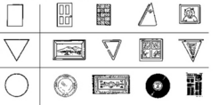

Plane Figures HW
WEDNESDAY
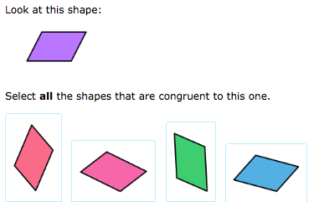

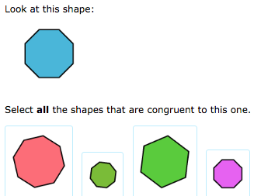

www.forrestmath.weebly.com
THURSDAY
Part I: Identify the name/number of plane figures that you see in the following:

1. __________________

2. ____________ ______________

3. _____________ ______________

Part II: Describe the following:

4. How are squares and rectangles similar? ________________
____________________________________________________

5. How are squares and rectangles different? _______________
____________________________________________________

