Name ____________________________
WEDNESDAY
Directions: Label the following geometric patterns.
1) qQqQqQ
_____ _____ _____ _____ _____ _____

2) b T T b T T
___ ___ ___ ___ ___ ___ ___ ___

3) Bobby made this pattern by repeating the
first four shapes in the order as shown.

The pattern continues in the same way. What will be the next shape in Bobby’s pattern?

A C

B D

4) Look at the pattern of blocks below.

?

Term 1 Term 2 Term 3 Term 4 Term 5
How many blocks should be in Term 5? ________

www.forrestmath.weebly.com
Patterns HW
THURSDAY
Directions: If the pattern continues…

1) If the pattern continues, describe what the next 3 shapes would be.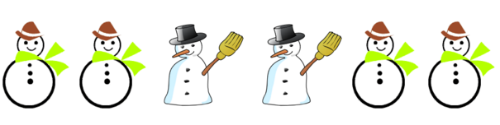
____________, ____________, ____________

2) If the pattern continues, describe what the next shape would be.
___________________________________________________

3)

If this growing pattern continues, how many squares will
be in the next figure?

F 10 H 16

G 13 J 21

