Name _________________________________
MONDAY
Part I: Geometric Patterns
Directions: Label the pattern and then find the set that shows the same pattern.

1) Which of the following has this same pattern?

F

G

H

J

Part II: Numeric Patterns
2) What is the rule for the pattern below?

5 | 10 | 15 | 20 | 25

F subtract by 2 H add 5

G subtract by 5 J add 30
Patterns and Counting HW
TUESDAY
Part I: Numeric Patterns

1) What is the next term in this growing pattern?

7, 8, 10, 13, 17, _____

2) Julie created the pattern shown below.

2, 5, 8, 11, 14, 17, …

Which of the following is a pattern with the same rule.

A 1, 4, 7, 10, 13, …
B 4, 7, 10, 11, 12, …
C 6, 9, 12, 15, 16, …
D 3, 6, 7, 8, 9, …

3) Look at this pattern of numbers: 50, 46, 42, 38, 34, …

Which of the following statements is TRUE?

A This is a growing pattern.
B This is a pattern of numbers less than 33.
C This is a repeating pattern.
D This set of numbers does not have a pattern.

4) What is the rule for this growing pattern?

22, 26, 30, 34, 38…

A add 2 C add 4
B subtract 4 D subtract 4

www.forrestmath.weebly.com
WEDNESDAY
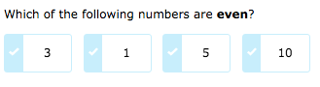
1)

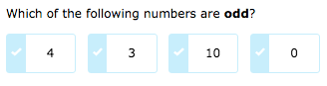

2)

3) Circle the sets that have an even number of fruit, put an X on the sets that have an odd number of fruit.

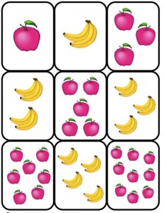

www.forrestmath.weebly.com
THURSDAY
Directions: skip count by 2, 5, or 10.

1) Starting at the number fourteen, skip count by two.

______, ______, ______, ______, ______, ______, ______

2) Starting at the number 35, skip count by five.

______, ______, ______, ______, ______, ______, ______

3) Starting at the number twenty, skip count by ten.

______, ______, ______, ______, ______, ______, ______

Circle all of the following that are NOT correctly counting by twos:

4 6 8 10 12 15 18 20

64 66 68 70 72 74 76 78

20 25 30 35 40 45 50 55

70 72 74 76 78 80 82 84

