Name _______________________________________________
Directions: Count up the following sets of bills/coins. Write the amount on the line using the $ or c correctly.

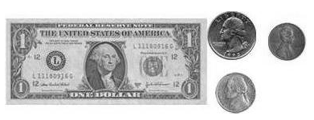
1)

__________________

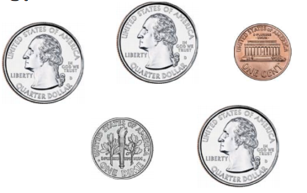
2)

_________________

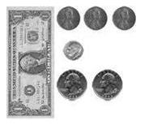
3)

_______________

MONEY HW #2
Directions: Count and compare the money shown below.

1) Shade the set of coins that is the least
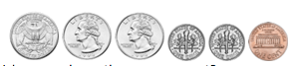

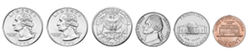

2) Shade the set of money that is greater
