Name _________________________________
MONDAY
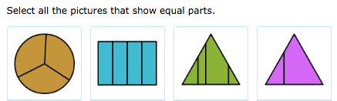

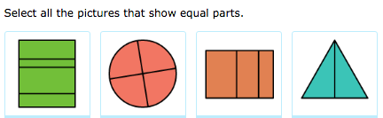

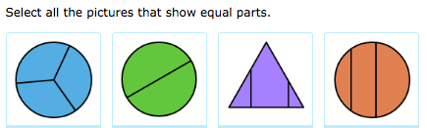

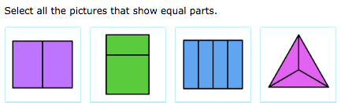

www.forrestmath.weebly.com
Identifying Fractions HW
TUESDAY
Directions: Write the fraction beside the model and then draw a line to match the fraction below with their correct name in word form.
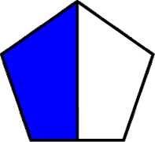

One third

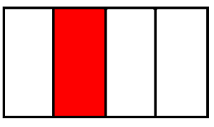

One tenth

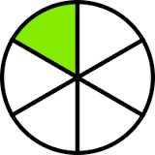

One sixth

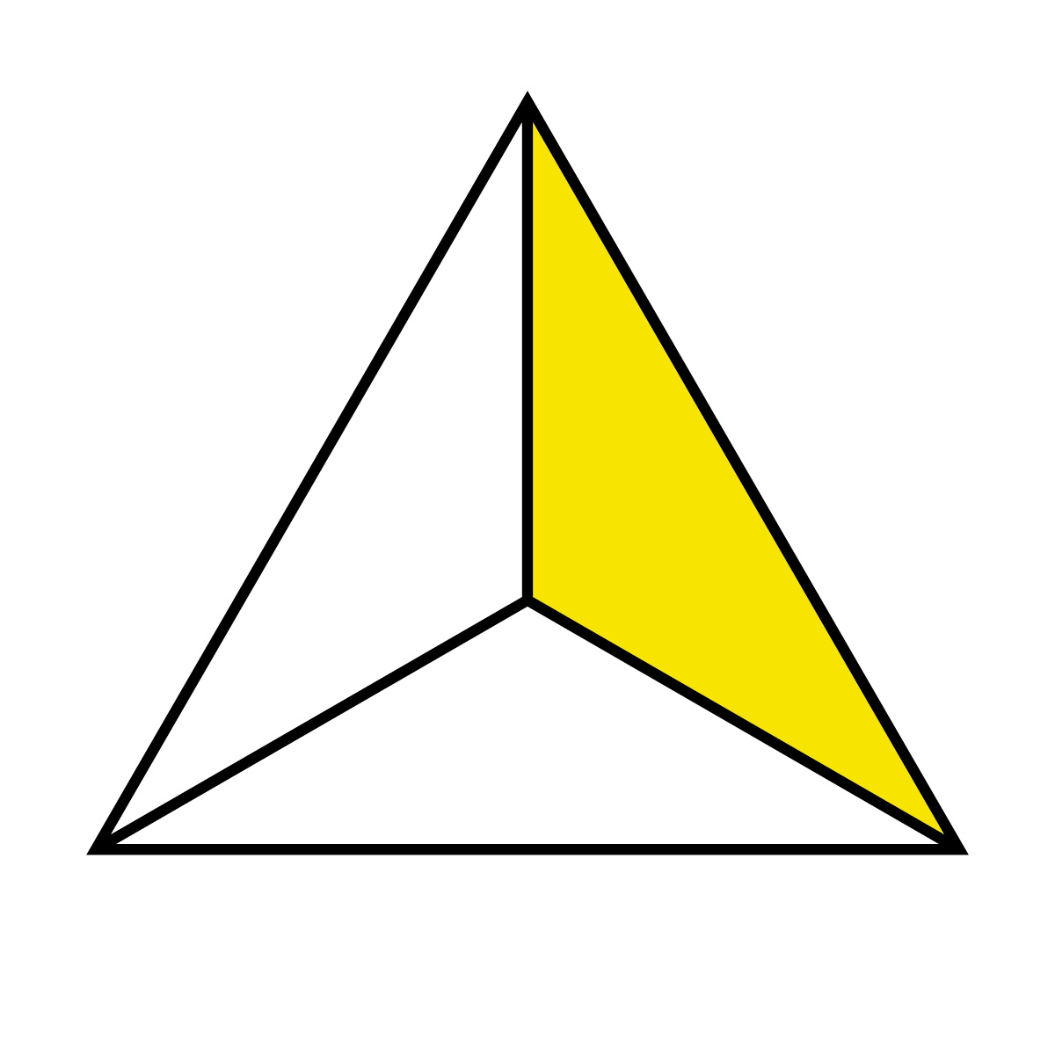

One half

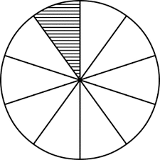

One fourth

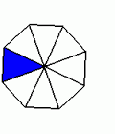

One eighth

WEDNESDAY
Directions: Shade the following models to show the correct fraction.
Fraction | Model
3*
7! ) | 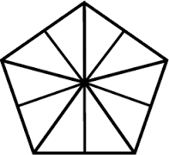
2@ or 1 whole | 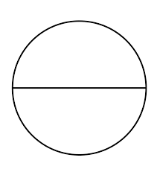
2#
5^ | 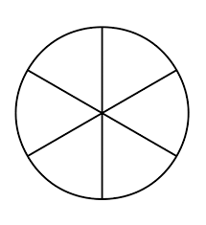
www.forrestmath.weebly.com
THURSDAY
Directions: Circle the fraction that fits each model.
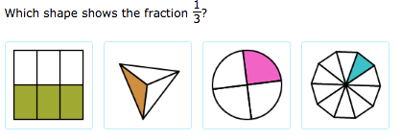
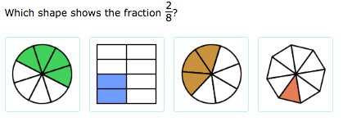
Directions: write the fraction for each model.

What fraction of the blocks are light grey?

What fraction of the t-shirts are striped?
