Name ________________________________
MONDAY
Part I: The bar graph below shows the favorite sports of students in Mr. Johnson’s class. Choose all correct statements about the graph.
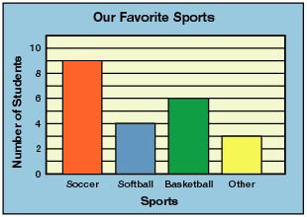
- There are a total of 18 students in Mr. Johnson’s class
- More students like baseball more than softball
- All of the students in Mr. Johnson’s class like football
- 15 student chose soccer or basketball as their favorite sport
- Most of the students chose soccer as their favorite sport

Part II: Use the above graph to answer the following questions.

2. How many more students like soccer instead of softball and other combined?
___________

3. How many people liked softball and baseball combined?
___________

4. What is the graph interval counting by?
___________
Graphing HW #2
TUESDAY
Part I: Use the data in the table below to create a horizontal bar graph. Fill in the title, labels, and flavors of ice cream.
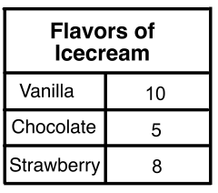
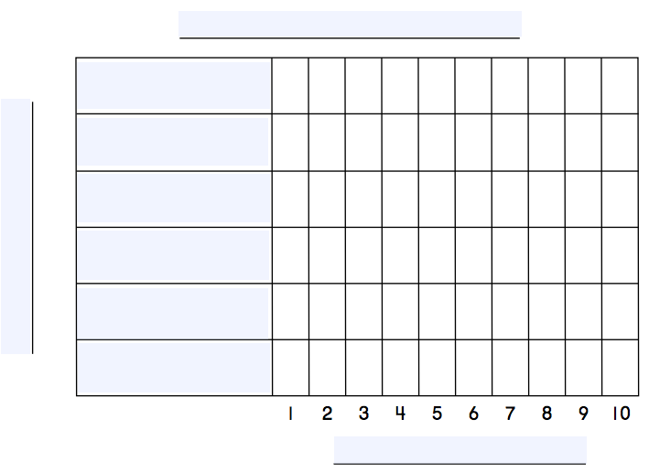

1. How many people voted for their favorite ice cream flavor? _____

2. How many more people liked chocolate AND strawberry than vanilla?
______
www.forrestmath.weebly.com
WEDNESDAY
Part I: Use the pictograph below to answer the following questions.
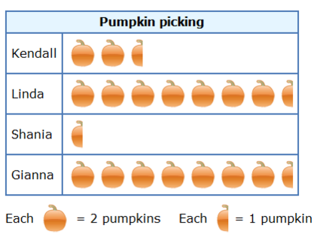
1. How many pumpkins did Kendall pick? ______

2. How many pumpkins did Shania and Gianna pick together?
________

3. How many pumpkins were picked? _______

4. Which two girls picked the same number of pumpkins?
_______________ and ________________

5. How many more pumpkins did Linda pick than Kendall?
________

6. True or False. Gianna picked eight pumpkins: ___________

7. True or False. Kendall and Shania picked six pumpkins _____
THURSDAY
Part I: Use the table and tally marks to create a pictograph below. Use the key to complete your graph. Include a title.
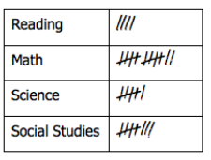

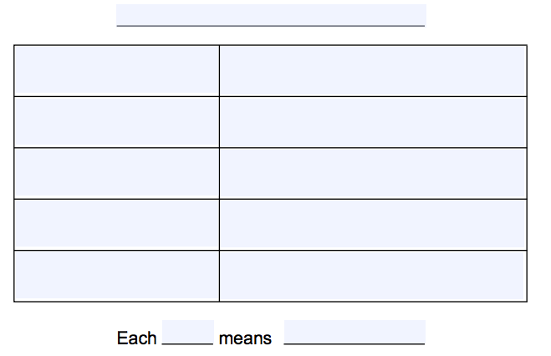

1. If each picture equals two votes, how do you represent one vote?
_____________________________________________________

2. Which subject the second highest number of votes? __________

Create your own addition question using the graph above.
3. ______________________________________________________
________________________________________________________
________________________________________________________

