Name ________________________________
TUESDAY

Part I: Define Difference and Estimate

1) Explain what you are doing when you are asked to find the difference in math ____________________________________

2) Explain what you are doing when you estimate a number
________________________________________________________________________________________________________

Part II: Use the place value blocks to find the difference between the two numbers.

3)
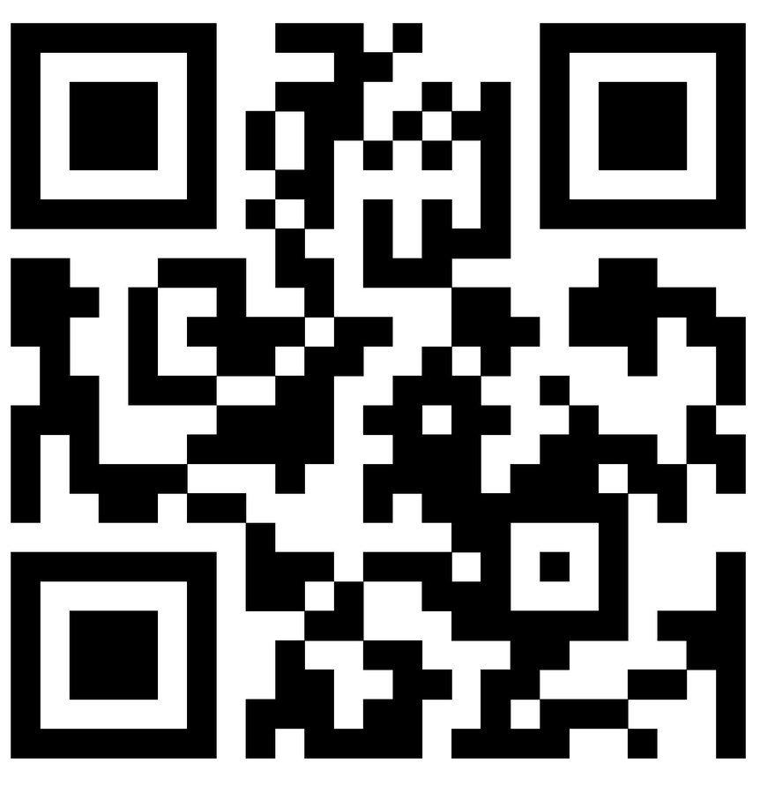
ppppppppg – ppppl =

A 85 B 49 C 44 D 36

4)
pppppppppg - ppppppppl =

A 95 B 89 C 16 D 6

www.forrestmath.weebly.com
Finding Differences (Subtraction)
WEDNESDAY

Part I: Estimate the following numbers

1) 68 _________ 2) 17 __________

Part II: Answer the following

3) Dawn wanted to estimate the difference: 68 – 17 =
Which numbers should she use?

A 60 – 17 C 70 – 20
B 60 – 20 D 60 – 10

4) Jeff sold 56 bars of candy and Tim sold 89 bars of candy.
To find how many more bars of candy Tim sold than Jeff, we should-

F add H divide
G subtract J multiply

Part III: Subtract

5) 6 4 6) 7 8 7) 9 3
- 3 1 - 5 7 - 4 6

THURSDAY
Part I: Use the place value blocks to answer the following questions.

1) One p is the same as ________ q
2) When I break apart p, I get ______ q

Part II: Find both the estimated and actual answers to the following problems.

3) 5 6 4) 6 3
- 1 4 - 3 4

4) 4 2 5) 3 0
- 2 3 - 2 1

Part I: Answer the following subtraction word problems.

1) Stashka drank 64 ounces of water in the morning and 81 ounces of water in the afternoon. About how much more water did Stashka drink in the afternoon than in the morning?

______ ounces

2) The chart below shows the top children’s books read
by a group of boys and girls.

Top 4 Books | Read by Girls | Read by Boys
The Lost Hero | 24 | 56
Elf on the Shelf | 45 | 35
The Ugly Truth | 40 | 40
Of Thee I Sing | 67 | 13
Of thee I Sing was written by President Obama to his daughters. How many more girls read Of thee I Sing than boys?

A 13 B 54 C 67 D 80

3) Jeff sold 56 bars of candy and Tim sold 89 bars of candy. How many more candy bars the Tim sell over Jeff?

_______ candy bars

www.forrestmath.weebly.com

