Name _________________________________
MONDAY
Start at the top and follow the directions to create your ice cream cone:
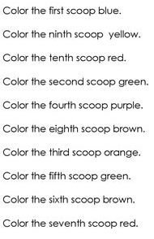

Match the ordinal numbers below:
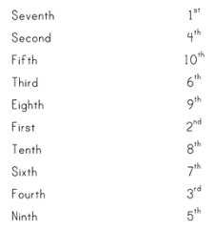

Ordinal Numbers HW
TUESDAY
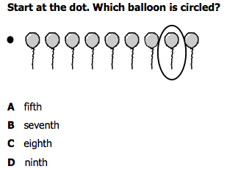
1)

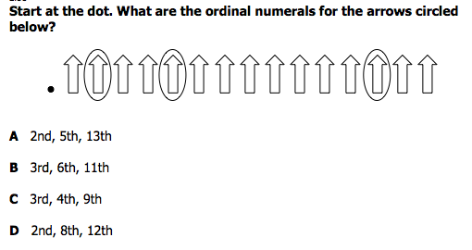
2)

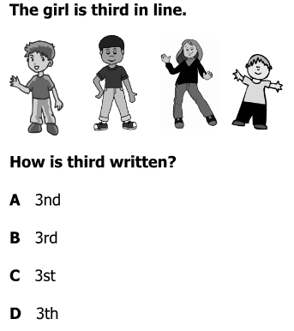
3)

www.forrestmath.weebly.com
WEDNESDAY
Part I: Identify the parts of the calendar

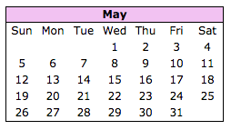
1. Circle the month
2. Put a rectangle around the days of the week
3. Lightly shade the dates

Part II: Use the calendar above to identify specific days and dates.

4. What date is the 3rd Monday in May? _________

5. How many Fridays are there in May? ________

6. How many days are in the Month of May? ________

7. Memorial Day is May 27th. What day of the week is May 27th? _______

8. What date is the second Sunday in May? ______

9. The 4th Friday in May is an early release day. What date is The 4th Friday in May? ___________

Calendar HW
THURSDAY
Part I: Answer the following calendar related questions.

1. How many months are in 1 year? ______

2. List the names of the months: ______________, ______________, ______________, ______________, ______________, ______________, ______________, ______________, ______________, ______________, ______________, ______________.

3. How many days are in 1 week? ________

4. List the days of the week: ______________, ______________, ______________, ______________, ______________, ______________, ______________

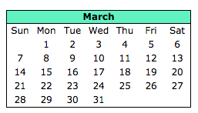
Part II: Using the calendar below, answer the following questions.

5. St. Patrick’s Day is on Wednesday, March 17th. What is the date exactly one week after St. Patrick’s Day? _____________

6. What day will it be four days before March 30th? __________

www.forrestmath.weebly.com

