Name ________________________________
MONDAY
Part I: Use the place value blocks below to complete each subtraction problem. Write the subtraction fact below.

Ex. jy - y = j
13 - 6 = 7

1. ka - m =

2. vzcb - f =

3. ggg - ff =

4. pj - m =

Basic Subtraction HW
TUESDAY
Part I: Solve the following.

1. What is the difference between 14 and 5? ________

2. What is seven less than ten? ________

3. What is 17 minus 11? ________

4. What is five fewer than twelve? _______

Part II: Answer each subtraction problem. Draw place value blocks if needed.

5) 18 – 12 = _____ 6) 9 – 4 = ______ 7) 2 – 2 = ______

8) 11 9) 7 10) 9 11) 15
- 8 - 6 - 3 - 4

Part III: Solve the following subtraction word problems.

12) I started out the week with 12 pencils. On Thursday I only had 3 left. How many pencils did I lose?

13) Mrs. Tonkin had 21 kids in her class. 5 of them moved away. How many kids are in her class now?

www.forrestmath.weebly.com
WEDNESDAY
Review: Skip Counting

Count by tens
0 | 10 |  | 30 | 40 |  |  | 70 |  | 90

Count by fives
25 | 30 |  | 40 |  |  | 55 |  | 65

Count by twos
48 | 50 | 52 |  |  | 58 |  | 62

Part II: Solve the following subtraction problems.

1) 18 - _____ = 7 2) ____ - 9 = 11

3) _____ - 11 = 2 4) 20 - _____ = 7

5) 17 - _____ = 3 6) _____ - 13 = 5

Part III: Shade in all correct answers.

7) Select all of the ways to make 1:
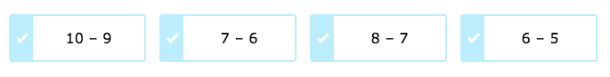

8) Which is not a way to make 3?

9) Which is not a way to make 9?
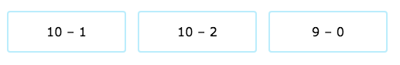

THURSDAY
Part I: Create a subtraction problem for each of the following graphics.

1) 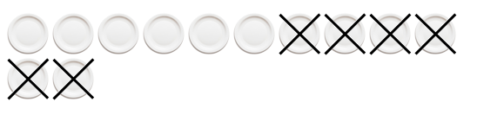
_______________________

2)
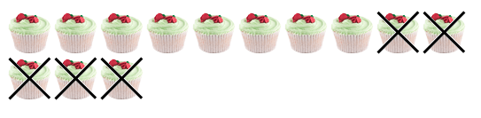
_______________________

3) 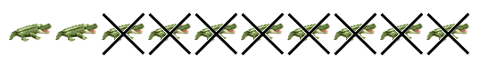
_______________________

Part II: Solve the following word problem.

4) There are 18 horses on an island. There are 2 tame horses. How many horses are wild?
__________

www.forrestmath.weebly.com

