Name _________________________________
MONDAY

Match the vocabulary word with the correct graphic.
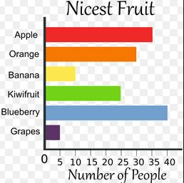
_____ bar graph A)

_____ tally marks

_____ grid

_____ table
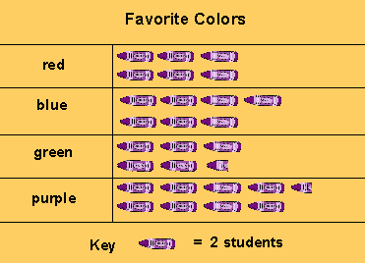
_____ picture graph B)

E)

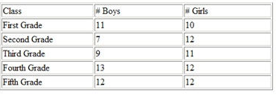
C)

D)

www.forrestmath.weebly.com

Graphing HW
TUESDAY

Part I: Represent the following data using tally marks.
Favorite Sport
Sport | Number | Tally Marks
Football | 13
Soccer | 10
Baseball | 15
Hockey | 7
Part II: Analyze a bar graph
Directions: use the bar graph to answer the following questions.
1. What is the title of this graph? ________________

2. Is this graph horizontal or vertical? ________________

3. Which fruit was the nicest? _________________

4. How many people liked grapes and bananas? _____

5. What is the scale counting by? __________

7. How many more people thought that bananas were nicer than grapes? _________________

WEDNESDAY

Picture Graphs
Directions: Use the picture graph below to answer the following.
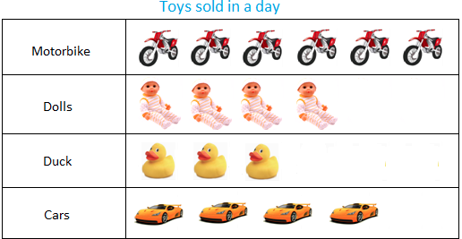

1. Is there a key for this picture graph? ________
2. How much is each picture worth? ________
3. How many cars and motorbikes were sold? _______
4. How many more dolls were sold than cars? _______

Directions: Use the pictograph below to answer the following.
5. What does the key tell you? __________________

6. How many people liked the color purple? _________

7. Which color did people like more, red or green? _______

8. How many more people liked purple more than red? ______

Part II: Use one of the graphs above to create your own addition problem.
____________________________________________________________________________________________________________________________________
Test Practice
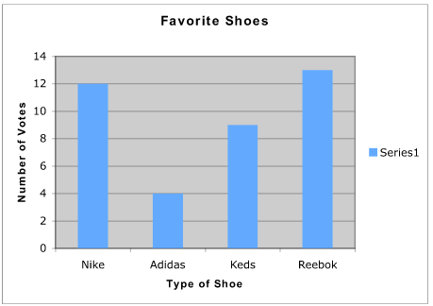
THURSDAY

What information can NOT be determined from this graph?

F the number of votes for Nike
G the shoe with the highest number of votes
H the shoe size for the type of shoes
J how many more people voted for Reebok® than Adidas®

Which statement is FALSE?

F Nike® has 12 votes H Keds® has 8 votes
G Adidas® has 4 votes J Reebok® has 13 votes

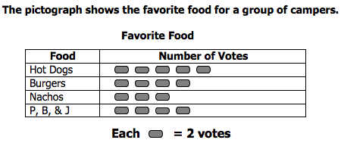

Which foods have the same number of votes?

F Hot Dogs and Nachos H Burgers and P, B, & J
G Hot dogs and Burgers J Burgers and Nachos

What is the total number of campers?

A 16 B 22 C 30 D 32

