Name __________________________________
MONDAY
Directions: Solve the following.

1) 45 + 44 2) 67 + 19 3) 18 + 37

4) 63 5) 48
+ 35 + 48

Preview: Skip Counting
Count by tens
0 | 10 |  | 30 | 40 |  |  | 70 |  | 90

Count by fives
25 | 30 |  | 40 |  |  | 55 |  | 65

Count by twos
48 | 50 | 52 |  |  | 58 |  | 62

Review: Rounding

6) When I woke up this morning it was 54 degrees. What is 54 rounded to the nearest ten?
________

Write down five numbers that, when rounded to the nearest ten, would round to 90.

_____ _____ _____ _____ _____

Addition HW
TUESDAY
Directions: Solve the following.
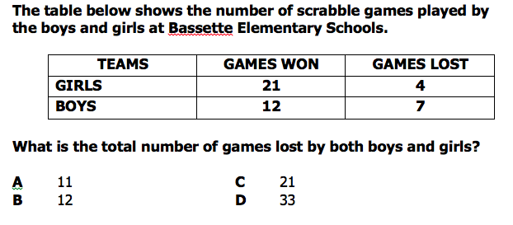
1)

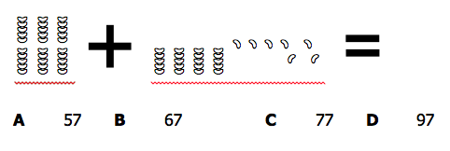
2)

Review: Place Value
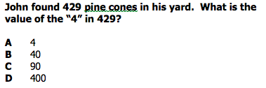
3)

www.forrestmath.weebly.com
WEDNESDAY
Part I: Use grid paper to complete the following addition problems.
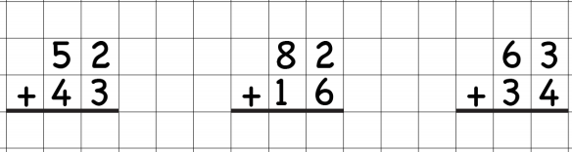

Part II: Use grid paper to complete the following addition with regrouping problems.
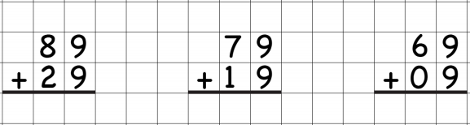

Explain how you know when you should regroup when adding:
____________________________________________________________________________________________________________________________________
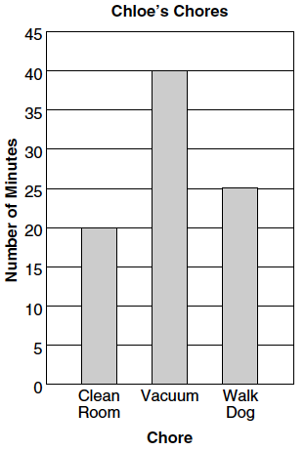
Review
The bar graph to the right shows the
number of minutes it takes Chloe to do
each chore.
How many minutes does it take Chloe to
clean her room and walk the dog all
together?
A 25 C 45
B 35 D 60
THURSDAY

1) Jordan earned 46 dollars raking leaves and 45 dollars delivering newspapers. Does he have enough money to buy a scooter that costs $99? How much does he have saved?

2) It is 37 miles from Mrs. Dobrowlski’s house to Forrest Elementary. How many total miles does she have to drive to and from school?

3) Lunch is 25 minutes, recess is 15 minutes, and resource is 40 minutes. About how much time do you get away from your classroom each day?

Review
Andy, Bob, Charles, and David went on a fossil hunt. The graph shows the number of fossils each boy found.
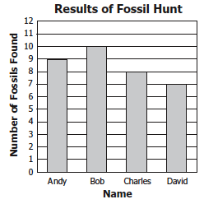

1 How many more fossils did
Bob find than David?
F 3 H 17

G 2 J 18

2 What was the total number of
fossils found altogether?

A 34 C 27

B 31 D 24

www.forrestmath.weebly.com

